**BUILDING NAME EMERGENCY EVACUATION PROCEDURES**

**Evacuation** must take place when the building is **no longer safe** or **potentially unsafe**

e.g. if there is a **fire** – *no matter how small* – or suspected bomb.

1. Building evacuation alarm: [**DESCRIBE *THE NOISE THAT WILL ALERT EVERYONE*** *TO GET OUT*] **___________________**

**Note: SOUND of “siren” or “alarm” in the building MUST be DESCRIBED (these vary greatly all over campus) so visitors/newcomers ALSO know what to expect! e.g. “wailing siren”, “continuous high-pitched beeping”, “repeated blasts of whistle”, “ringing hand bell”, etc.**

1. ALL occupants must leave by the nearest marked exit, and alert others to do the same.
2. Fire marshal(s) assist – also people with mobility/hearing/sight disabilities.
3. First aider(s) take a first aid kit – in case of injuries/burns.
4. Keep clear of outdoor fire hydrants, walkways & roads – for use by emergency vehicles & personnel.
5. ALL occupants must go to Emergency Assembly Point 1: [***specify*** *where you will meet*] **______________________**

**MUST be approx. 50 metres away from building - to avoid injury from falling/burning items, exploding glass windows, etc.**

*(only use alternative if point 1 is deemed unsafe by Coordinator - Point 2: [****specify****]* ***______________________****)*

1. All doors: Emergency Coordinators put up signs “Building Evacuated – proceed to Emergency Assembly Point”.
2. Building Emergency Coordinator conduct roll call – to check all occupants have exited safely.
3. Occupants only return to building once directed to do so by Fire Officer / Emergency Coordinator.

**BUILDING NAME EMERGENCY TEAM** [*insert details below*]

|  |  |  |  |
| --- | --- | --- | --- |
| **Emergency Coordinator**(s): | | Name Surname **[SENIOR staff e.g HOD]**  RU ext, cell number | Name Surname **[DEPUTY]**  RU ext, cell number |
| **Health & Safety Rep**(s): | | Name Surname  RU ext, cell number | Name Surname  RU ext, cell number |
| **First Aider**(s): **Or WHO will carry the first aid kit during evacuation - in case of injuries/burns.** | | Name Surname  (L1/3 valid to month year)  RU ext, cell number | Name Surname  (L1/3 valid to month year)  RU ext, cell number |
| **Nearby First Aider**(s): **look up names on list at** [**www.ru.ac.za/safety/firstaid/rufirstaiders**](http://www.ru.ac.za/safety/firstaid/rufirstaiders) | | **(details of nearby First Aider)** Name Surname  (L1/3 valid to month year)  RU ext, cell number | **(details of another nearby First Aider)** Name Surname  (L1/3 valid to month year)  RU ext, cell number |
| **Fire Marshals** [floor monitors/incident officers] | | **Marshal**: | **Deputy**: |
| ***Assist people with disabilities*** | Specify area in building | Name Surname  RU ext, cell number | Name Surname  RU ext, cell number |
| Specify area in building | Name Surname  RU ext, cell number | Name Surname  RU ext, cell number |
| Specify area in building | Name Surname  RU ext, cell number | Name Surname  RU ext, cell number |

|  |  |  |
| --- | --- | --- |
| **Area or floor** | **Location of fire-fighting equipment**: | **Type**: |
| Specify area in building | Insert details e.g. *Passageway outside kitchen* | Insert details e.g. DCP (dry powder) 4.5 kg |
| Insert details e.g. *outside door of office 11* | Insert details e.g. C02 (carbon dioxide) 2 kg |
| Specify area in building | Insert details | Insert details e.g. Fire hose (water) |
| Insert details | Insert details |
|  | [*delete or insert additional rows - as required*] |  |

**IMPORTANT EMERGENCY NUMBERS**

|  |  |  |
| --- | --- | --- |
| **AMBULANCE:** | **CAMPUS PROTECTION UNIT:** | **FIRE:** |
| Private service - Gardmed:  **073 065 6660**  Provincial service:  **046 622 9102** or **10177** | Central reporting point for all incidents at RU:  **046 603 8147** / **8146** / **8999** | Makana Fire & Rescue Services:  **046 622 4444**  or toll-free:  **080 111 4444** |
| **HOSPITAL:** | **POLICE:** | **POISON:** |
| Settlers Hospital:  **046 602 5000**  Fort England Hospital:  **046 602 2300** | Grahamstown SAPS:  **046 603 9146** or **9147** / **9152** | Unitas Hospital Poison Centre:  **0800 333 444**  Red Cross & Tygerberg Hospital Poison Info Helpline:  **0861 555 777** |
| **RU HEALTH CARE:** | **STAFF/STUDENT CONCERNS:** | **RU WELLNESS:** |
| RU Health Care Centre:  **046 603 8523** or after hours:  **082 801 1409** | Human Resources Division (staff):  **046 603 8112**  Division of Student Affairs:  **046 603 8181** | RU Counselling Centre:  **046 603 7070**  or afterhours:  **082 803 0177** |
| **NATIONAL EMERGENCY CALL CENTRES and TRAUMA COUNSELLING:** | | |
| National police emergency:  **10111**  National toll-free emergency number:  **112** | Mobile App - [www.mysos.co.za](http://www.mysos.co.za) (requires registration):  **mySOS SA** | Lifeline national (sharecall):  **0861 322 322**  SA Institute for Traumatic Stress:  **011 648 7376** / **77** |

Available online at [www.ru.ac.za/safety/emergencies](http://www.ru.ac.za/safety/emergencies)

**BUILDING NAME EMERGENCY EVACUATION - FLOOR PLAN**

*NB: Please contact Zamuxolo Tambo <Z.Tambo@ru.ac.za> for a PDF of your building floor plan. Use “Snipping Tool” to take images out of the PDF file and insert into your MS word doc… then go to “Layout Options”, select “Wrapping Options”, select “Behind Text”. Then use arrows, text boxes etc to show escape routes, exits, etc, as per example below.*

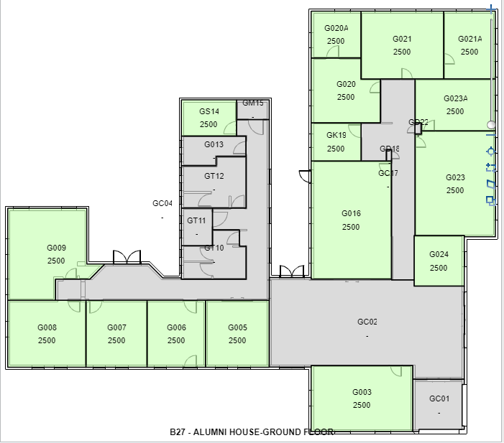

**EXIT**



store

**Emergency Assembly Point 2**

example - Bicycle Sculpture

Lucas Avenue



**Emergency Assembly Point 1**

example - Blockhouse Lawn



EXAMPLE

**EXIT**

**GUIDELINES: WHAT TO DO IN AN EMERGENCY / FIRE**

|  |  |
| --- | --- |
| **F**  **FIND** the fire | 1. If you see or smell smoke, immediately find out where it is. |
| **I**  **INFORM** all | 1. Warn occupants as soon as possible.  * Alarm may be automatic / manual / repeated blasts of whistle |
| **R**  **REPORT** to emergency services | 1. Call **CPU EMERGENCY ext 8999** (or 8146) as soon as possible.  * Provide the following info:   Building + Department / floor where the fire is + Your Name   * CPU will contact Makana Fire and Rescue Services. * Call your Building Emergency Coordinator if possible   NEVER TRY to CONTROL a FIRE BEFORE CALLING FOR HELP. |
| **E**  **EXTINGUISH** fire if safe to do so | 1. Use fire fighting equipment to control the fire, ONLY if:  * It is small enough to be contained, and * You know how to operate the extinguisher (pull out the pin!)   AVOID BEING TRAPPED: keep your back to an EXIT. |
| **G**  **GET GOING** | 1. Even if a fire extinguisher is being used, make sure everyone starts evacuating.   IF the FIRE CANNOT be CONTROLLED SAFELY, LEAVE IMMEDIATELY. |
| **E**  **EVACUATE** | 1. Evacuate the building in an orderly manner. DO NOT PANIC:  * Check that all occupants leave the building. * Assist anyone with mobility / hearing / sight challenges. * Follow EXIT signs and alert others to do the same.   If there is THICK SMOKE, keep AS LOW AS POSSIBLE, or CRAWL. |
| **A**  **ASSEMBLE** outside | 1. All occupants go to the Assembly Point (at least 50 metres away) or  * Alternative Assembly Point announced by Emergency Coordinator * Keep clear of the building   DO NOT OBSTRUCT emergency vehicles and personnel |
| **R**  **RETURN** only when instructed | 1. Only return to the building once directed to do so by the Makana Fire Officer or building Emergency Coordinator. |

This document, “*Emergency Evacuation Plan of Action GENERIC‌‌*”, is available online at [www.ru.ac.za/safety/fire/firedrills](http://www.ru.ac.za/safety/fire/firedrills), [www.ru.ac.za/safety/fire/evacuation](http://www.ru.ac.za/safety/fire/evacuation) & <http://www.ru.ac.za/safety/emergencies>